***P1***

***Part 2 - Select a motherboard image, draw arrows to identify the North Bridge and South Bridge chipset, write an outline description of what each bus will do.***

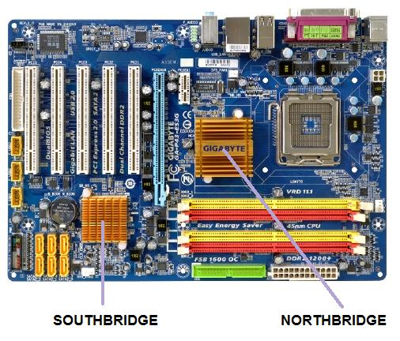I am going to be talking about the North Bridge and South Bridge chipsets of the motherboard. They are only two chipsets on the motherboard, one being Northbridge and the other Southbridge. A chipset is important for the motherboard. This is a set of electrical components on the motherboard, which manages the data flow of the memory, processor andperipherals. As you can see on the motherboard below, the Northbridge and Southbridge is present. Unlike Southbridge, Northbridge acts like a “bridge” and it is directly connected to the CPU. Therefore, the Northbridge is connected to the CPU, RAM, AGP and Southbridge. Southbridge has no connection to the CPU. For information to reach to Southbridge, it must be passed through Northbridge to reach to Southbridge. Updated computers have more than one chipset on their computer. As you can see on the image, the Northbridge is slightly bigger than Southbridge. Of course, the upgraded versions are much better. They can be both into one chip.